We’ve done the WhatsApp integration through Twilio. To connect to it, please use the following steps:

1. Contact the number +1 (415) 523-8886 through WhatsApp
2. Type anything and you should receive an instruction message as shown in the following screenshot

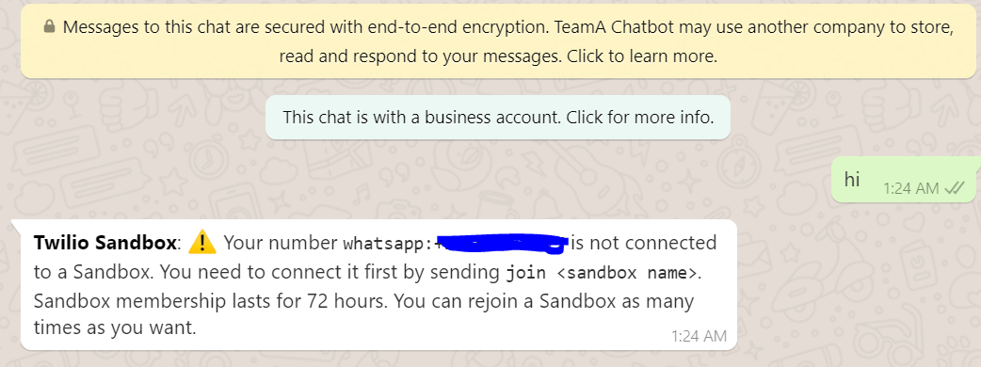

1. Type the phrase *Join buy-believed* and you should be able to connect to Teleri

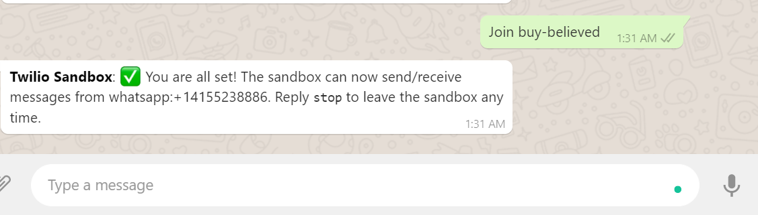

1. Now, you can start the conservation with Teleri and know about your favorite TV shows. Enjoy her company!

